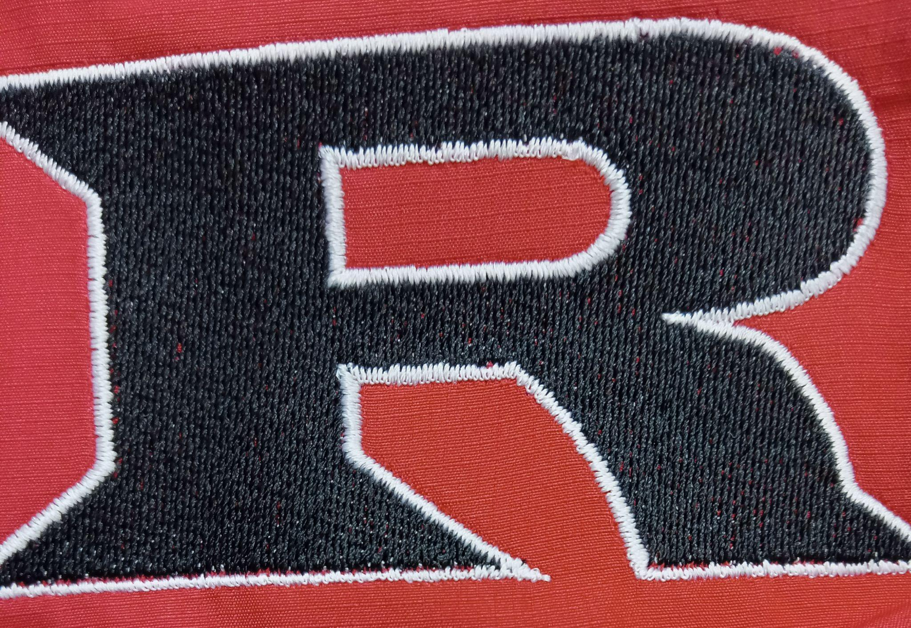
2023 5th & 6th / JH Football Schedule
(UPDATED 8-23-2023)
Monday August 28 Kremlin Away 5:30/6:30

Tuesday September 5 Waynoka Home 5:30/6:30

Tuesday September 12 Garber Away 5:30/6:30

Monday September 18 Covington Away 5:30/6:30

Monday September 25 Cherokee Away 5:30/6:30

Monday October 2 Canton Home 5:30/6:30

Monday October 9 Timberlake Home 5:30/6:30

Monday October 17 DCLA Home 5:30 **GS ONLY**

Head Coach: Eric Bradley
Assistants: Kyle Hatfield
Principal: Kyle Stewart
Athletic Director: Amanda Stinnett
Superintendent: Wade Detrick

