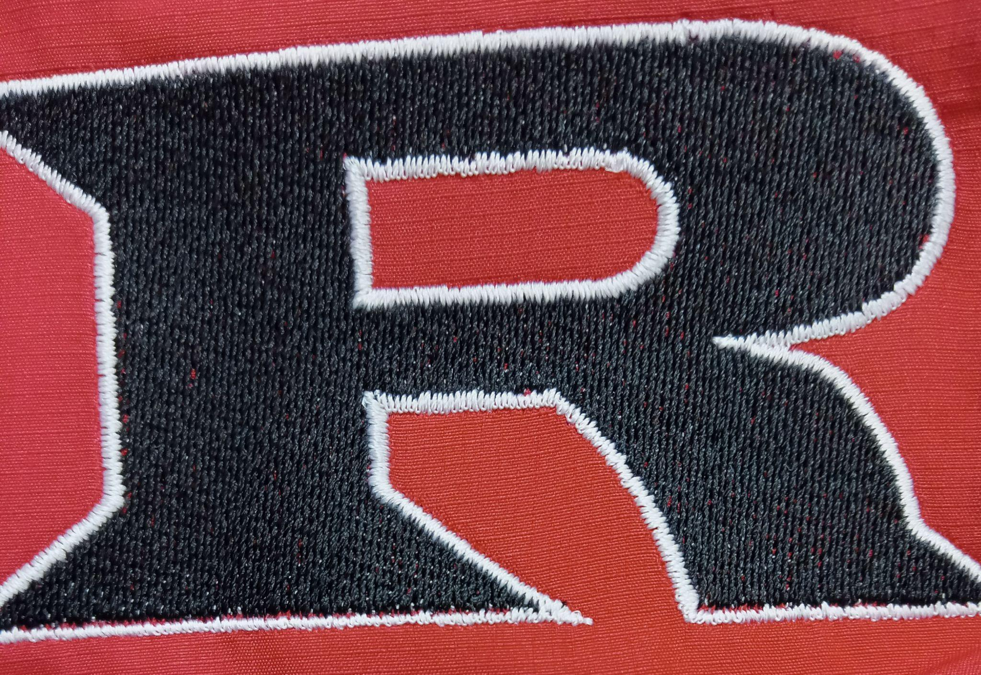

2023 HS Football Schedule

August 18 Okeene Scrimmage Away Friday 6PM

August 24 Waukomis Scrimmage Home Thursday 6PM

September 1 Timberlake Away Friday 7PM

September 7 Covington Home Thursday 7PM
(ALUMNI NIGHT)
September 15 Waynoka Home Friday 7PM
(Homecoming)
September 22 Canton Away Friday 7PM

September 29 Turpin Home Friday 7PM
(Pink out week)
October 5 Kremlin Away Thursday 7PM

October 13 OBA Home Friday 7PM
(First Responders Night)
October 20 PCH Away Friday 7PM

October 27 Garber Home Friday 7PM
(Senior Night)
November 3 Cherokee Away Friday 7PM

Head Coach: Eric Bradley
Assistants: Kyle Hatfield, Dallas Hunt, Jeff Schmidt
Principal: Kyle Stewart
Athletic Director: Amanda Stinnet
Superintendent: Wade Detrick

