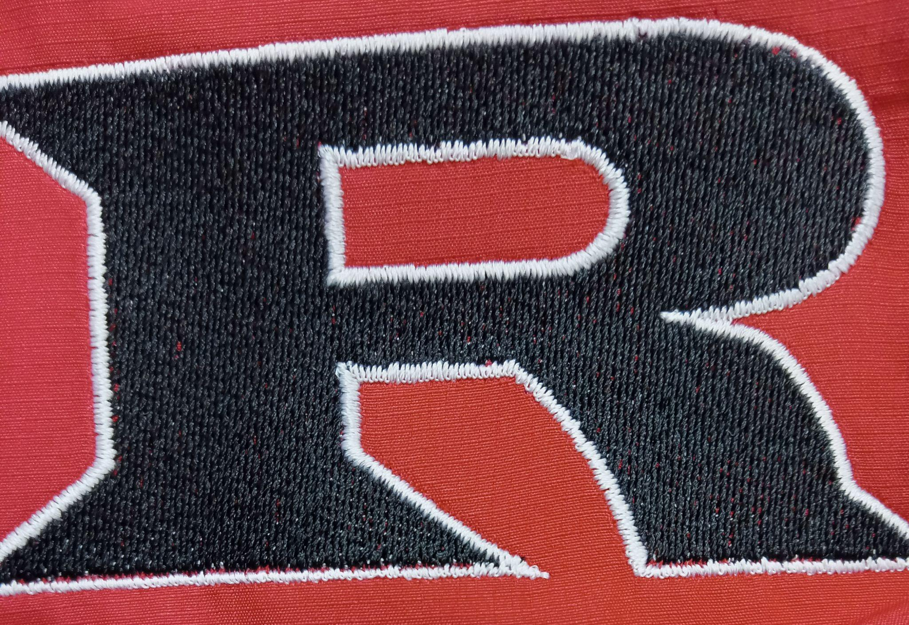
2022 5th & 6th / JH Football Schedule

Monday August 29 Kremlin Home 5:30/6:30

Tuesday September 6 Waynoka Away 5:30/6:30

Tuesday September 13 Garber Home 5:30/6:30

Monday September 19 Covington Home 5:30/6:30

Monday September 26 Cherokee Home 5:30/6:30

Monday October 3 Canton Away 5:30/6:30

Monday October 10 Timberlake Away 5:30/6:30

Head Coach: Eric Bradley
Assistants: Sam Baker, Brandon Bittner
Principal: Kyle Stewart
Athletic Director: Amanda Stinnett
Superintendent: Wade Detrick

