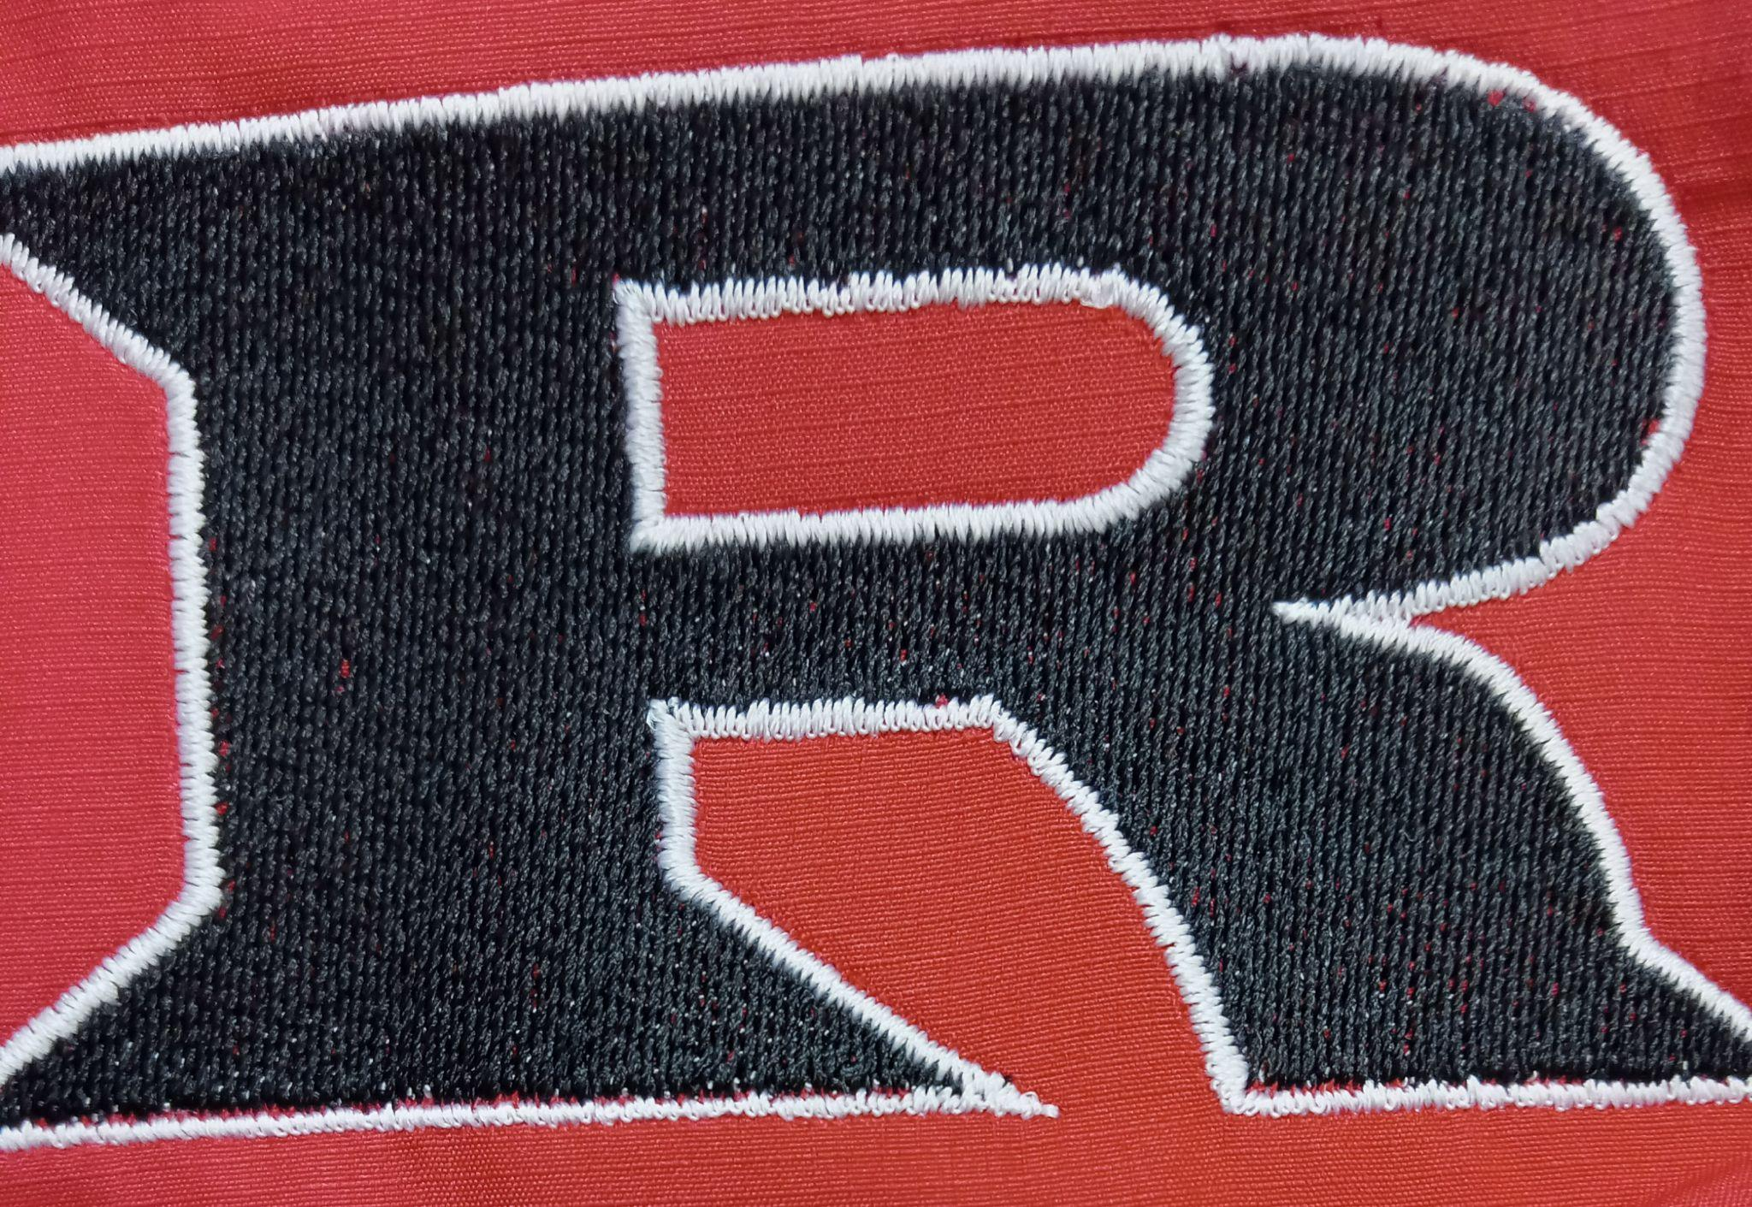
2022 HS Football Schedule

August 19 6:00 Buffalo(scrimmage) Away Friday

August 25 6:00 Waukomis(scrimmage)Home Thursday

September 1 7:00 Timberlake Home Thursday
(Alumni Night)
September 9 7:00 Covington Away Friday

September 16 7:00 Waynoka Away Friday

September 23 7:00 Canton Home Friday
(Homecoming)
September 30 7:00 Turpin Away Friday

October 6 7:00 Kremlin Home Thursday (Pink Out)
October 13 7:00 OBA Away Thursday

October 20 7:00 PCH Home Thursday
(Law Enforcement Night)
October 28 7:00 Garber Away Friday

November 4 7:00 Cherokee Home Friday
(Senior Night)
Head Coach: Eric Bradley
Assistants: Sam Baker, Brandon Bittner
Principal: Kyle Stewart
Athletic Director: Amanda Stinnet
Superintendent: Wade Detrick

