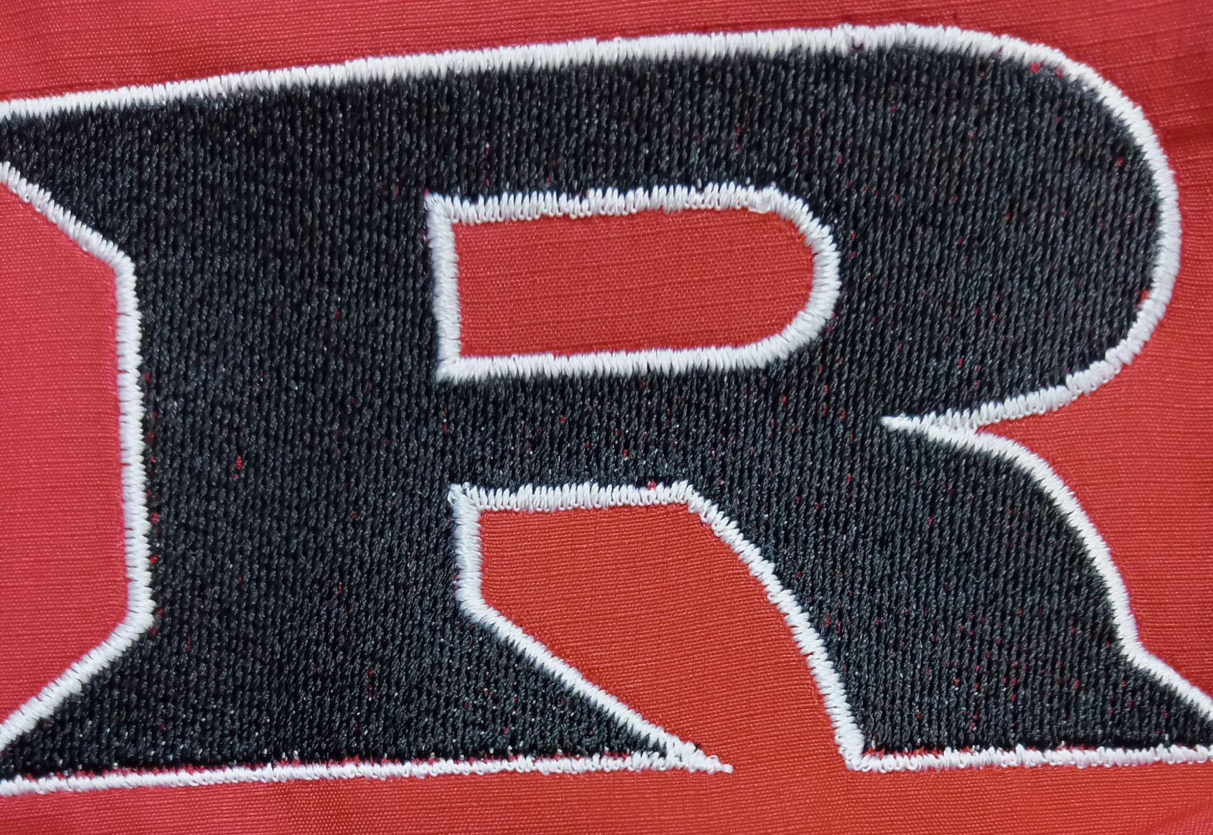
2023 JH Track Schedule

March 28th Medford 2:30 PM
April 6th Home 9:00 AM
April 11th Thomas 8:30 AM
April 17th Hennessey 8:00 AM
April 24th Covington Douglas 8:00 AM

Head Coach: Eric Bradley
Principal: Kyle Stewart
Athletic Director: Amanda Stinnett
Superintendent: Wade Detrick

