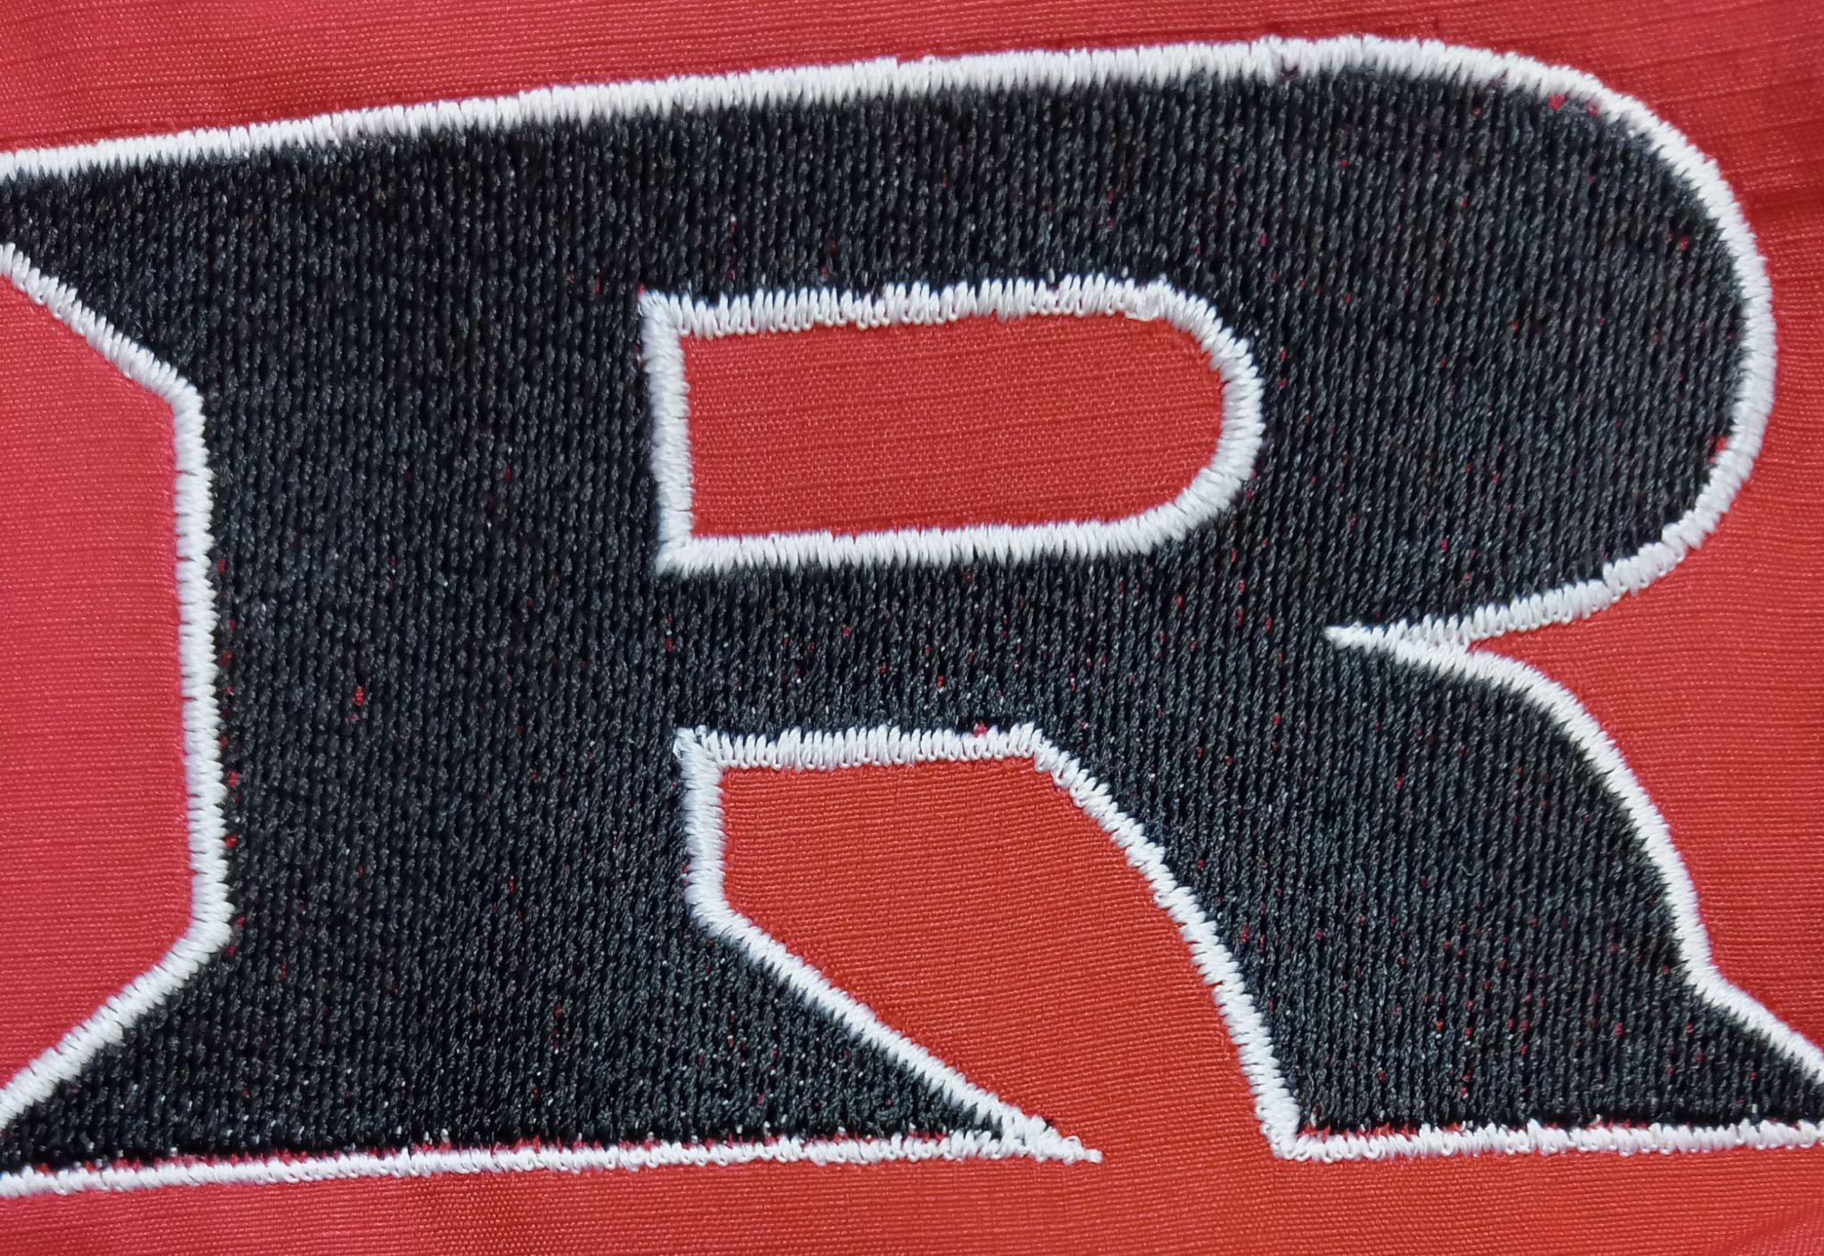
2022 HS Track Schedule

March 28th Medford 2:30 PM
April 13th Home 9:00 AM
April 18th Deer Creek-Lamont 7:45 AM
April 22nd Home 9:00 AM
April 24th Covington Douglas 8:00 AM
April 29th Regional 6:00 AM
May 5th-6th Western Heights(State) 6:00 AM

Head Coach: Eric Bradley
Principal: Kyle Stewart
Athletic Director: Amanda Stinnett
Superintendent: Wade Detrick

